The University of South Australia
School of Health Sciences

Does habitual exposure to a body part in a third person perspective alter the cortical strategies used to make left/right judgements?

Thank you for your interest in this research study.
The research team consisting of Louisa Edwards (Physiotherapy Honours student), Dr. Tasha Stanton (NHMRC Post-Doctoral Research Fellow with the Body and Mind Research Group at the University of South Australia) and Mr. Ryan Causby (Podiatry lecturer) thanks you for your interest in participating in this voluntary study of left/right discrimination ability. You have been asked to participate because you are either a health care professional (podiatrist or hand therapist) or because you are healthy (and do not work in these professions).

Contact:
Dr. Tasha Stanton
- Em: Tasha.Stanton@unisa.edu.au
- Ph: 08 8302 2090

Background information:
The purpose of this study is to determine what factors impact your ability to perform a left/right judgement task. The left/right judgement task involves seeing pictures of hands or feet and you must decide whether the pictured image is of a right hand or a right foot. We know that this task evaluates how well the areas of your brain that monitor movement of a body part actually work. When asked to judge whether an image of a hand is of a left or right hand, a subject will mentally manoeuvre his or her own hand into that position. This is referred to as implicit motor imagery. The accuracy of the answer and time taken to respond are important measures of this ability. Our study aims to determine whether individuals who regularly see another persons’ hands or feet (such as podiatrists and hand therapists) bypass this motor imagery process. Specifically, this study aims to determine if regularly seeing hands and feet from a third-person point of view (for example, seeing someone else’s hands and feet in front of you) changes how accurately and quickly one can perform these judgements.

Why is this important?
By understanding the strategies used to undertake these left/right judgements and factors that might change how someone performs these judgements, we may be better able to determine a person’s response to a treatment called graded motor imagery. Graded motor imagery (GMI), involving left/right judgements, explicit motor imagery and mirror theory, is a common form of management for people suffering from ailments such as chronic pain, spinal cord injury and motor neurone diseases.

What would your role be?
If you choose to participate, you would be required to complete a ~30-40 minute session of left/right judgements of hand and feet images on a laptop or desktop computer. This would include a questionnaire aimed at determining handedness and general demographics, a short practice session and then the true session. The process is completed entirely online.
In formal testing, images such as those presented below will be presented on screen for five seconds each and in succession. This testing will consist of 80 images of hands and 80 images of feet, presented in eight different orientations ranging from first to third person perspectives, and this will be repeated twice.

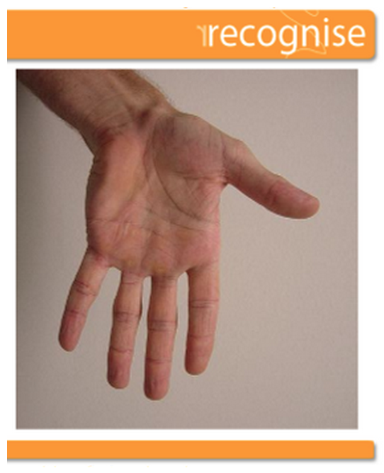
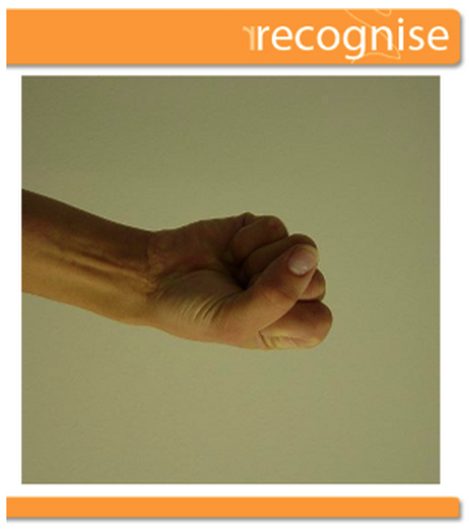
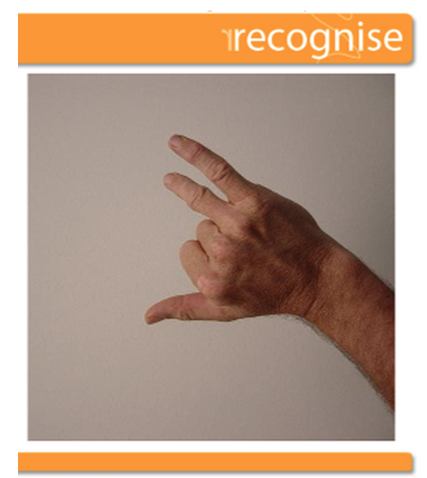

Is there any benefit to me?
We cannot and do not guarantee that you will receive any benefits from this study.

Is there any risk to me?
There are no identifiable risks to taking part in this study. Participation in this study is voluntary and participants are free to withdraw from the research project at any time without affecting their status now or in the future.

What will happen to my results?
You will see your overall results of accuracy and reaction time for images of hands and feet immediately following completion of the left/right judgement task. We will export all data from the online software program to a statistics program for analysis. All data will be non-identifiable and thus participants will remain anonymous. Data will be kept for 5 years in electronic format on password protected computers and spreadsheets at the Body in Mind Research Group, University of South Australia. Results will be reported in scientific publications in a way in which you cannot be identified. If you would like to know about the final results of this study, you will be prompted to enter your email address at the end of the test. This email address will not be linked to your test results, so you will remain anonymous.

Your decision whether or not to participate will not prejudice your future relations with the University of South Australia and its teaching hospitals. If you decide to participate you are free to withdraw your consent and to discontinue your participation at any time without prejudice. We consider your completion of the online tests to imply consent.

If you have any questions, Dr. Tasha Stanton (ph. 08 8302 2090 or tasha.stanton@unisa.edu.au) will be happy to answer them.

This project has been approved by the University of South Australia's Human Research Ethics Committee. If you have any ethical concerns about the project or questions about your rights as a participant please contact the Executive Officer of this Committee, Tel: +61 8 8302 3118; Email:vicki.allen@unisa.edu.au

